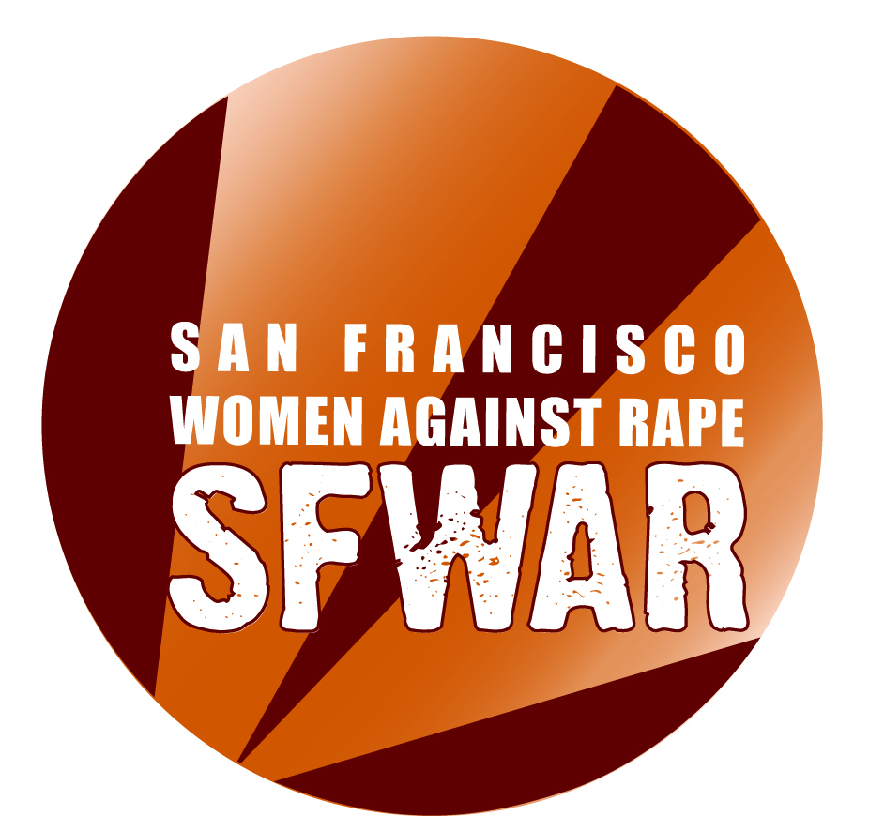

UNCERTIFIED VOLUNTEER CONTRACT

NAME: ___________________________________________DATE: ___________________

As an Outreach Volunteer with SFWAR, I agree to:

- Complete __________ hours by ___________ (deadline).
- I will volunteer ____ hours per week / month (please circle)

My general schedule will be as follows:

Monday | Tuesday | Wednesday | Thurs | Fri | Sat | Sun
 |  |  |  |  | (office closed) | (office closed)

- At SFWAR we believe that working against all forms of oppression, including racism, sexism, classism, homophobia, transphobia, ablelism, etc., is important for doing anti-rape work and ending violence in our communities. As an outreach volunteer, I understand I will be a representative of SFWAR in the community and will act as such. This means I will respectful of community members, businesses and organizational partners. This also means I will refrain from engaging in oppressive behavior or language.

- Our work is also about consent. I will respect businesses, organizations, and individuals who choose not to support SFWAR outreach efforts and/or do not accept SFWAR material. I will not force any business, organization or individual to take SFWAR material.

- Safety is also a priority for SFWAR. As a volunteer I agree to prioritize my and the safety of my fellow volunteers. This means creating safe spaces when in the community. If I experience any hostility, rudeness, mocking, inappropriateness or harassment, I will immediately remove myself from the situation and return to SFWAR to report back. In addition, I agree to not engage in any verbal dispute regarding SFWAR.

- If I need to take a leave from volunteer service due to personal/ family/ medical emergency, I will re-negotiate my contract with the Director or Coordinator I am working with, so that we work out a way to fulfill the remainder of my contract once I am able to return to volunteer service.

- Find a replacement if for any reason I am unable to fulfill a responsibility I have already signed up for or otherwise agreed to. I understand I am fully responsible for my shift once I have indicated availability for it or received confirmation; finding a replacement is my responsibility and NOT the staff's. I will inform the office staff of the substitution before the shift happens.

- Work on issues of oppression and privilege both within myself and the organization, including anti-colonialism, anti-sexism, -racism, -classism, -ageism, and transphobia and other areas of oppression.
- If I wish to be reimbursed for transportation costs (bus or mileage) to and/or from outreach activity sites, I will submit my receipt to SFWAR within two weeks. I understand that I am only reimbursed for transportation costs while providing outreach activities.

- If I want to work more than 6 months, I will re-negotiate a new volunteer contract.

- Inform staff members about my feelings and perceptions regarding the work of SFWAR. If I have a problem or disagree with practices of the organization, I will discuss these with a staff member. Furthermore, I recognize that SFWAR considers the initiation of dating/intimate relationships between staff and volunteers inappropriate. Finally, I understand there is a grievance procedure if I need to use it.

- Know:
SFWAR's crisis line is 1 (415) 647-7273 (RAPE)
SFWAR's business line is 1 (415) 861- 2024
SFWAR's address – 3543 18th St. #7 (3rd Floor), San Francisco, CA 94110

SFWAR agrees to:

- Provide ongoing information, support, training, and supervision for volunteers to be able to complete outreach activities.

- Provide access to SFWAR's specialized book and video library on violence against women issues, per SFWAR Library policy.

- Provide support and feedback.

- Provide a forum to challenge ourselves about issues of oppression.

- Work with you to create a safe, supportive, and healing space for ourselves and the survivors and communities we work with.

- Work with you to develop a work schedule and environment that is empowering while addressing the needs of the whole organization.

- Provide additional opportunity to be trained in hotline counseling, medical advocacy and in-person counseling.

Failure to honor the above agreements will result in re-negotiating the contract or terminating the relationship.

Volunteer Signature: ________________________________________Date_______________

Staff Name: ____________________ Signature __________________________ Date________

